# Control Name: File Explorer

## Description

File Explorer is a Windows Explorer-like functionality for any web application. It allows end-users to browse, select and upload files, or change folder structure, by renaming, moving and deleting files or folders. File and folder management capabilities are fully customizable and can be disabled when necessary.

## Use Case

* Display folder and file structures
* Select multiple files
* Two file list view modes: Details and Thumbnails
* Automatically sort folders and files based on their names
* Automatically generate and display thumbnails for image files
* Rename, move and delete files and folders
* Create new folders
* Upload files using a built-in upload panel
* Update the file list dynamically
* Search for a file within a list quickly, using a built-in filter box.
* Customizable layout.
* Keyboard support for main file operations.
* In RTE control we can merge File Explorer for browsing image and file

## Research

Here using the target url of file system need to render the tree view. So by using target url need to get the file system details.

How to get the list of files or directories from file system? If we rename the file or directory or delete action happened means how it affect the file system.

In telerik, component one defined the file explorer controls. They get files details, file system processing on server side using C# code. So they used server side programming to implement the file explorer control.

Ref: <http://www.telerik.com/help/aspnet-ajax/fileexplorer-custom-filebrowsercontentprovider.html>

Demo: <http://demos.telerik.com/aspnet-ajax/fileexplorer/examples/overview/defaultcs.aspx>

Demo: <http://demo.componentone.com/ASPNET/ControlExplorer/C1FileExplorer/Overview.aspx>

**In telerik editor control.**

After analyzing the below file. I got information about how to make server request using Ajax and response, server side implementation for processing with File system. <http://www.telerik.com/clientsfiles/e3e38f54-7bb7-4bec-b637-7c30c7841dd1_KendoEditorImageBrowser.zip?sfvrsn=0>

## Existing Features/Information:

Not available

## Competitor Link:

Ref: <http://demos.telerik.com/aspnet-ajax/fileexplorer/examples/overview/defaultcs.aspx>

Ref: <http://demos.telerik.com/kendo-ui/editor/imagebrowser>

Ref:<http://www.ajaxfilebrowser.com/#http://www.ajaxfilebrowser.com/Userc2d1ac3/My%20Directory/>

Ref: <http://demo.componentone.com/ASPNET/ControlExplorer/C1FileExplorer/Overview.aspx>

Ref:<https://demos.devexpress.com/ASPxFileManagerAndUploadDemos/FileManager/Overview.aspx>

Ref:http://demo.essentialobjects.com/Demos/File%20Explorer/Features/Setting%20Root%20Folder/Demo.aspx

## External Reference Link:

Ref: <http://www.telerik.com/help/aspnet-ajax/fileexplorer-custom-filebrowsercontentprovider.html>

Ref: <http://www.telerik.com/clientsfiles/e3e38f54-7bb7-4bec-b637-7c30c7841dd1_KendoEditorImageBrowser.zip?sfvrsn=0>

Ref: <http://www.webdavsystem.com/ajaxfilebrowser/download/download>

Ref: <https://codeload.github.com/TomK/jquery.fileManager/zip/master>

## Prototype Sample Details:

Not available

## Implementation

**Basic Control structuring**

File explorer uses below mentioned controls

* Toolbar
* Tree view
* Grid
* Upload box
* Splitter
* Dialog
* Waiting popup
* Scrollbar

**To render the above mentioned 8Syncfusion controls, we need to create widget (JS script file) with basic necessary properties and methods**

### Features:

1. Feature 1

**Creating Tree and Grid structure**

First we need to get details of file/directory list and its properties from file system. Then only we can use these data to render tree view control.

1. Feature 2

**Need to give support for all tool bar tools**

1. Feature 3

**Image file need to be opened, when we click on the image file**

**Support for search bar**

#### Feature1

|  |
| --- |
| Things to do |
| In client side need to call server using Ajax to get the details from File System. |
| Server side implementation to get file/directory details |
| After getting details in client side. Need to render tree structure |
| Need to display grid view for selected folder in tree structure |

#### Feature 2

|  |
| --- |
| Things to do |
| Need to give support for Create, delete and rename tools in toolbar. We need server side methods to handle create, delete, rename process, which is raised from client side using Ajax. |
| Need to merge our upload box in toolbar as tool, which is used to upload the files |
| Need to give support for thumbnail view. Implement a tool in toolbar to switch between thumbnail view and grid view |
| Implement Refresh tool, which is used to display the refreshed file System content |

#### Feature 3

|  |
| --- |
| Things to do |
| If we click on the image file, we need to display the images in dialog box control |
| Implement Search bar, which is used to search the files easily from list of all file.  It need to filter the matched file, when we typing a file name in search bar. |

**Model Controls structure Demo**

Telerik FileExplorer

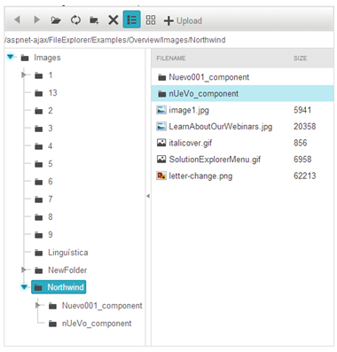

IT Hit Ajax File Browser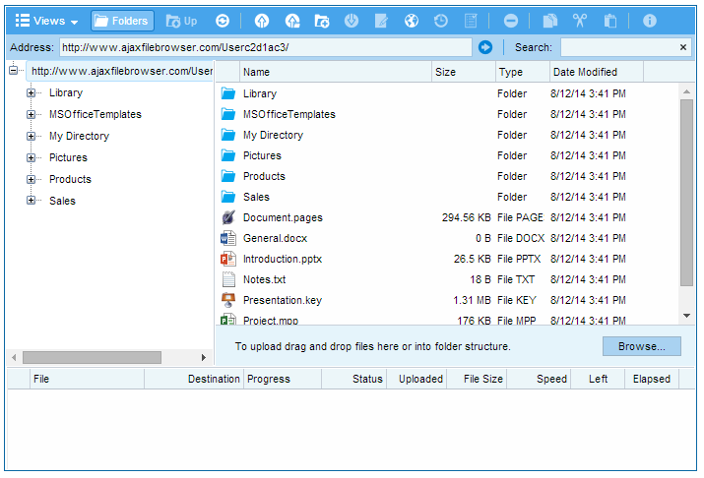

Kendo Editor –Image browser

